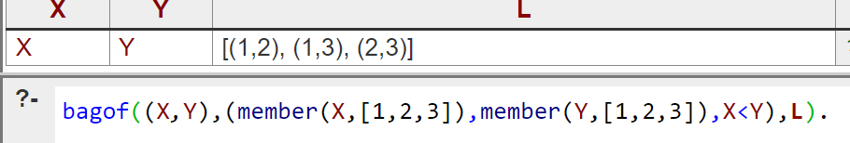

bagof((X,Y),(member(X,[1,2,3]),member(Y,[1,2,3]),X<Y),L).

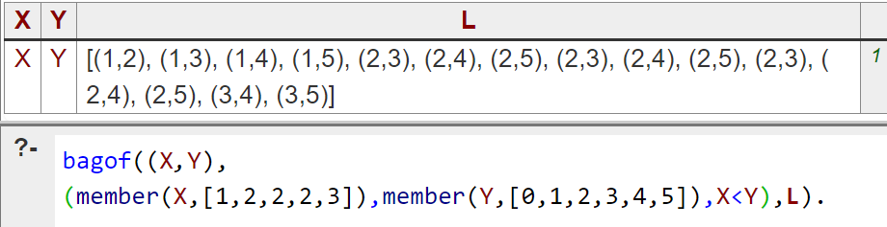

bagof((X,Y),

(member(X,[1,2,2,2,3]),member(Y,[0,1,2,3,4,5]),X<Y),L).

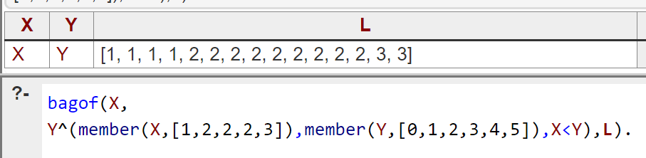

bagof(X,

Y^(member(X,[1,2,2,2,3]),member(Y,[0,1,2,3,4,5]),X<Y),L).

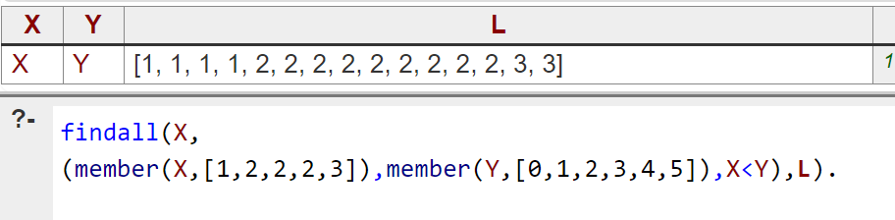

findall(X,

(member(X,[1,2,2,2,3]),member(Y,[0,1,2,3,4,5]),X<Y),L).

